CS 212: Object Oriented Programming

Class: BSCS-15

Lab02: Flow Control [Loops, Decisions & Arrays

Submitted By: Noor Fatima

CMS ID: 559891
Task 1:
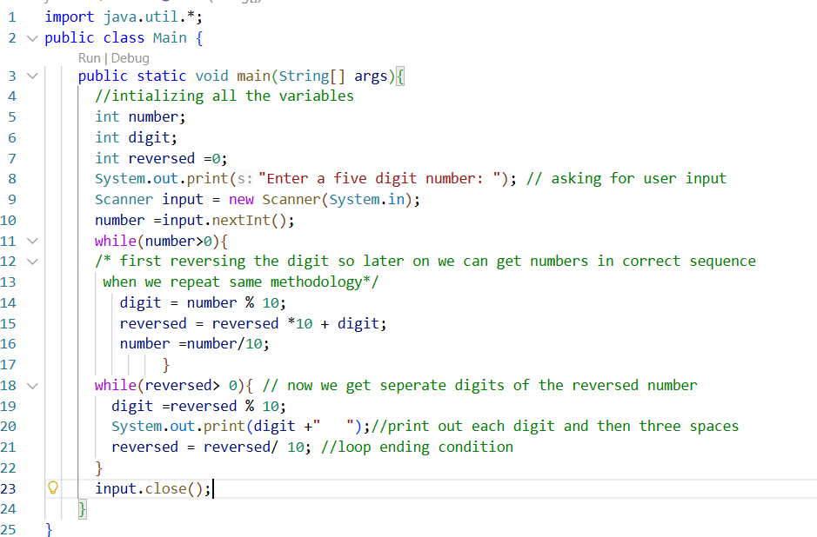

Output:

Answer:

The code will still run with more or less digits as the loop condition does not check if the number is less than or greater than five, it checks if any number is typed. So any number can be printed.
Task 2:
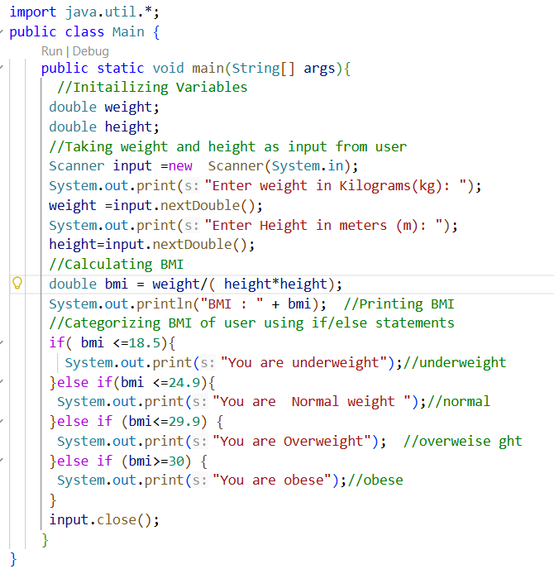
Output:

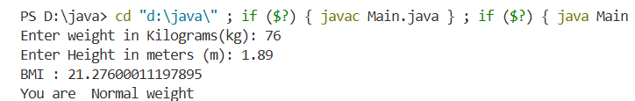

Task 3:

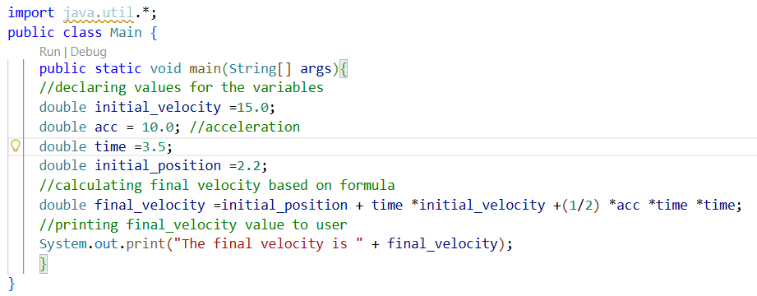
Output:
Task 4:
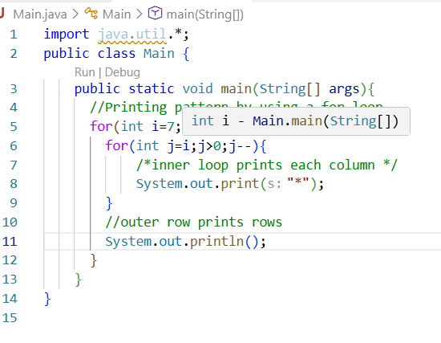
Output:
